**Industrial Internship Report on**

**”URL Shortner”**

**Prepared by**

**Aman Soni**

|  |
| --- |
| *Executive Summary* |
| This report provides details of the Industrial Internship provided by upskill Campus and The IoT Academy in collaboration with Industrial Partner UniConverge Technologies Pvt Ltd (UCT).  This internship was focused on a project/problem statement provided by UCT. We had to finish the project including the report in 6 weeks’ time.  My project was URL Shortener  This internship gave me a very good opportunity to get exposure to Industrial problems and design/implement solution for that. It was an overall great experience to have this internship. |

**TABLE OF CONTENTS**

1 Preface 3-4

2 Introduction 5

2.1 About UniConverge Technologies Pvt Ltd 5

2.2 About upskill Campus 9-10

2.3 Objective 11

2.4 Reference 11

2.5 Glossary 11

3 Problem Statement 12

4 Existing and Proposed solution 13

5 Proposed Design/ Model 14

5.1 High Level Diagram (if applicable) 14

5.2 Low Level Diagram (if applicable) 14

5.3 Interfaces (if applicable) 15

6 Performance Test 16

6.1 Test Plan/ Test Cases 16

6.2 Test Procedure 16

6.3 Performance Outcome 16

7 My learnings 17

8 Future work scope 18

# Preface

In the first week of this internship, I have learned about the introduction of python course and implementation of python in Data science. After Completion of this introduction, we get the project list in which I have to select one project for whole internship. This is the whole content of the first week. After the completion of this week, we learned about the control statements of python language and participate in Quiz-1 for test our knowledge or output. After completion of this quiz week 2 is complete and we start the next week content which is Implement of python in SEO and in Data Science. After completion of this third week, we have learned about the Roadmaps in Python Journey and Python packages such as NumPy and Pandas and difference between them. This is our whole Summary of 6 week.

The need of this type of Internship is very important for career development. Because these internship helps the people to explore his theoretical knowledge and enhance the practical knowledge by doing the real-world projects. As because newly intern / fresher is full of theoretical knowledge but have no experience in practical or real world.

In this Internship , The project which I have selected is URL shortener. This Project is used to generate the short manageable links(short URLs) from the Full URL (original URL) and make use these short manageable links in very efficient way.as because it is not very easy for common to learn the URL having well enough length .

Opportunity given by USC/UCT.

The Program was defined and organized in very efficient way as shown in fig below.

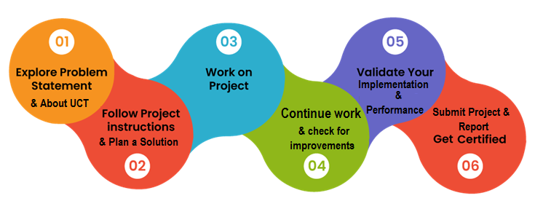

My learning and overall experience is very good after participation in this Program

Thanks to all members of IOT academy or Upskill Campus lectures and , who have helped you directly or indirectly.

The advice to junior from my side is that he/she must takes enough to decide his working field and area of interest. After when he/she able to find his interest, create a roadmap to explore his interest and knowledge about it for achieving the success in his life using his interest. His journey might be quite long but never taking the short way .Everyone must able to learn new things from the real world at any time.

# Introduction

## About UniConverge Technologies Pvt Ltd

A company established in 2013 and working in Digital Transformation domain and providing Industrial solutions with prime focus on sustainability and RoI.

For developing its products and solutions it is leveraging various**Cutting Edge Technologies e.g. Internet of Things (IoT), Cyber Security, Cloud computing (AWS, Azure), Machine Learning, Communication Technologies (4G/5G/LoRaWAN), Java Full Stack, Python, Front end**etc.



1. UCT IoT Platform **(****)**

**UCT Insight** is an IOT platform designed for quick deployment of IOT applications on the same time providing valuable “insight” for your process/business. It has been built in Java for backend and ReactJS for Front end. It has support for MySQL and various NoSql Databases.

* It enables device connectivity via industry standard IoT protocols - MQTT, CoAP, HTTP, Modbus TCP, OPC UA
* It supports both cloud and on-premises deployments.

It has features to  
• Build Your own dashboard  
• Analytics and Reporting  
• Alert and Notification  
• Integration with third party application(Power BI, SAP, ERP)  
• Rule Engine

 

1. **Smart Factory Platform (****)**

Factory watch is a platform for smart factory needs.

It provides Users/ Factory

* with a scalable solution for their Production and asset monitoring
* OEE and predictive maintenance solution scaling up to digital twin for your assets.
* to unleased the true potential of the data that their machines are generating and helps to identify the KPIs and also improve them.
* A modular architecture that allows users to choose the service that they what to start and then can scale to more complex solutions as per their demands.

Its unique SaaS model helps users to save time, cost and money.

 

1. 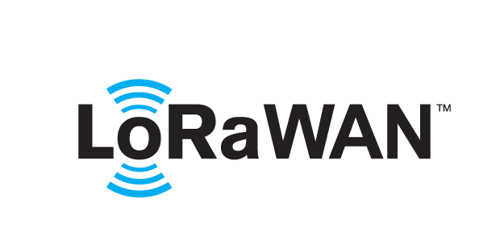 based Solution

UCT is one of the early adopters of LoRAWAN teschnology and providing solution in Agritech, Smart cities, Industrial Monitoring, Smart Street Light, Smart Water/ Gas/ Electricity metering solutions etc.

1. Predictive Maintenance

UCT is providing Industrial Machine health monitoring and Predictive maintenance solution leveraging Embedded system, Industrial IoT and Machine Learning Technologies by finding Remaining useful life time of various Machines used in production process.



## About upskill Campus (USC)

upskill Campus along with The IoT Academy and in association with Uniconverge technologies has facilitated the smooth execution of the complete internship process.

USC is a career development platform that delivers **personalized executive coaching** in a more affordable, scalable and measurable way.



Seeing need of upskilling in self paced manner along-with additional support services e.g. Internship, projects, interaction with Industry experts, Career growth Services

<https://www.upskillcampus.com/>

upSkill Campus aiming to upskill 1 million learners in next 5 year

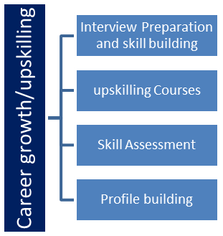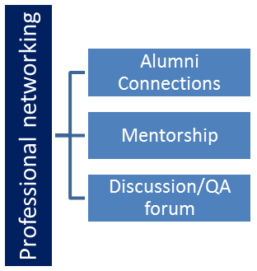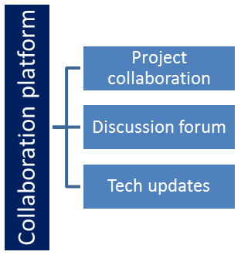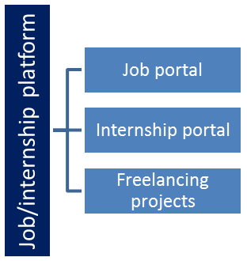

## The IoT Academy

The IoT academy is EdTech Division of UCT that is running long executive certification programs in collaboration with EICT Academy, IITK, IITR and IITG in multiple domains.

## Objectives of this Internship program

The objective for this internship program was to

 ☛ get practical experience of working in the industry.

 ☛ to solve real world problems.

 ☛ to have improved job prospects.

 ☛ to have Improved understanding of our field and its applications.

 ☛ to have Personal growth like better communication and problem solving.

## Reference

[1] https://learn.upskillcampus.com/s/store?redirectToMicroFE=false

[2] https://in.linkedin.com/company/upskillcampus

## Glossary

|  |  |
| --- | --- |
| Terms | Acronym |
| IOT | Internet of things |
| ML | Machine Learning |

# Problem Statement

URL Shortener

URL shortener is a Python project that converts long URLs into shorter, more manageable links. It is very hard to learn the URL for long time whose length is great enough. So, we need to use some techniques to solve this problem in such a way it takes the original full URL as input and generate the short and more manageable URLs. So because of this we can reach or access the original site by accessing these Short URLs.

# Existing and Proposed solution

These are so many technical and non-technical solution that are provided by other having so much limitations. First solution is that In place of creating short URLs ,people can create files in local System and stores as much as possible URLs in it . So that whenever he/she needed the URL can access from it. The limitation of this solution is

**a) Time Consuming and storage problem**

**b) Data Inconsistency possible**

**c) It is not always possible that whenever you need the URL you are able to access it.**

The next solution is to create files in cloud rather than local system. This solution is minimum the problems (like storage and speed)but not completely solve all problems(data inconsistency and chance of data to be leaked). The next solution that is provided by other is to create the routes in the server using js which takes the short URL and redirect to original or true site .

The solution that I have proposed is to create the server using python and Implement the functions which accepts the full URLs and generate the short URLs. After clicking the Short URLs the server redirect the user to true website of full URL.

## Code submission (Github link)

https://github.com/Aman-sir/URL-Shortner-using-Python.git

## Report submission (Github link) :.

https://github.com/Aman-sir/URL-Shortner-using-Python.git

# Proposed Design/ Model

The whole implementation of the project is shown in heading 5.1, 5.2, 5.3.

## High Level Diagram

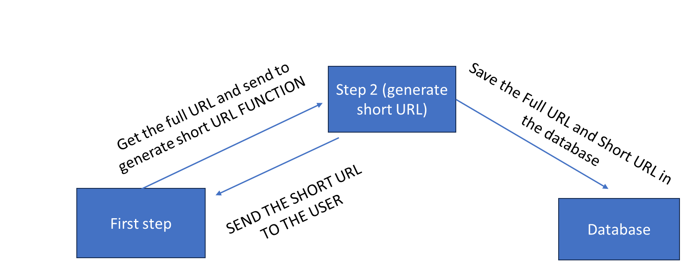

Figure 1: HIGH LEVEL DIAGRAM OF THE SYSTEM

## Low Level Diagram

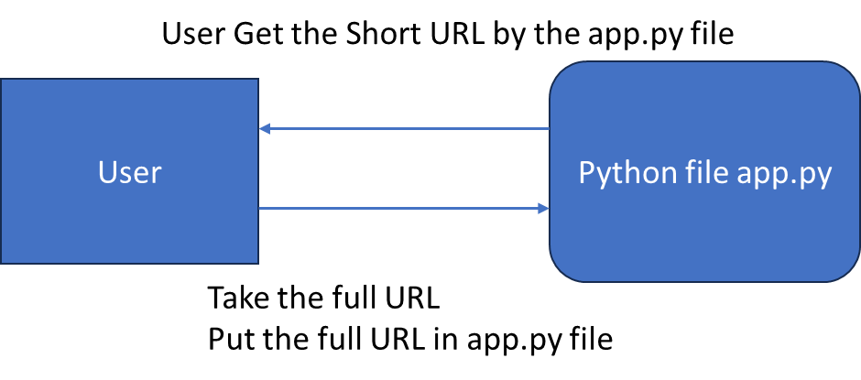

## Interfaces

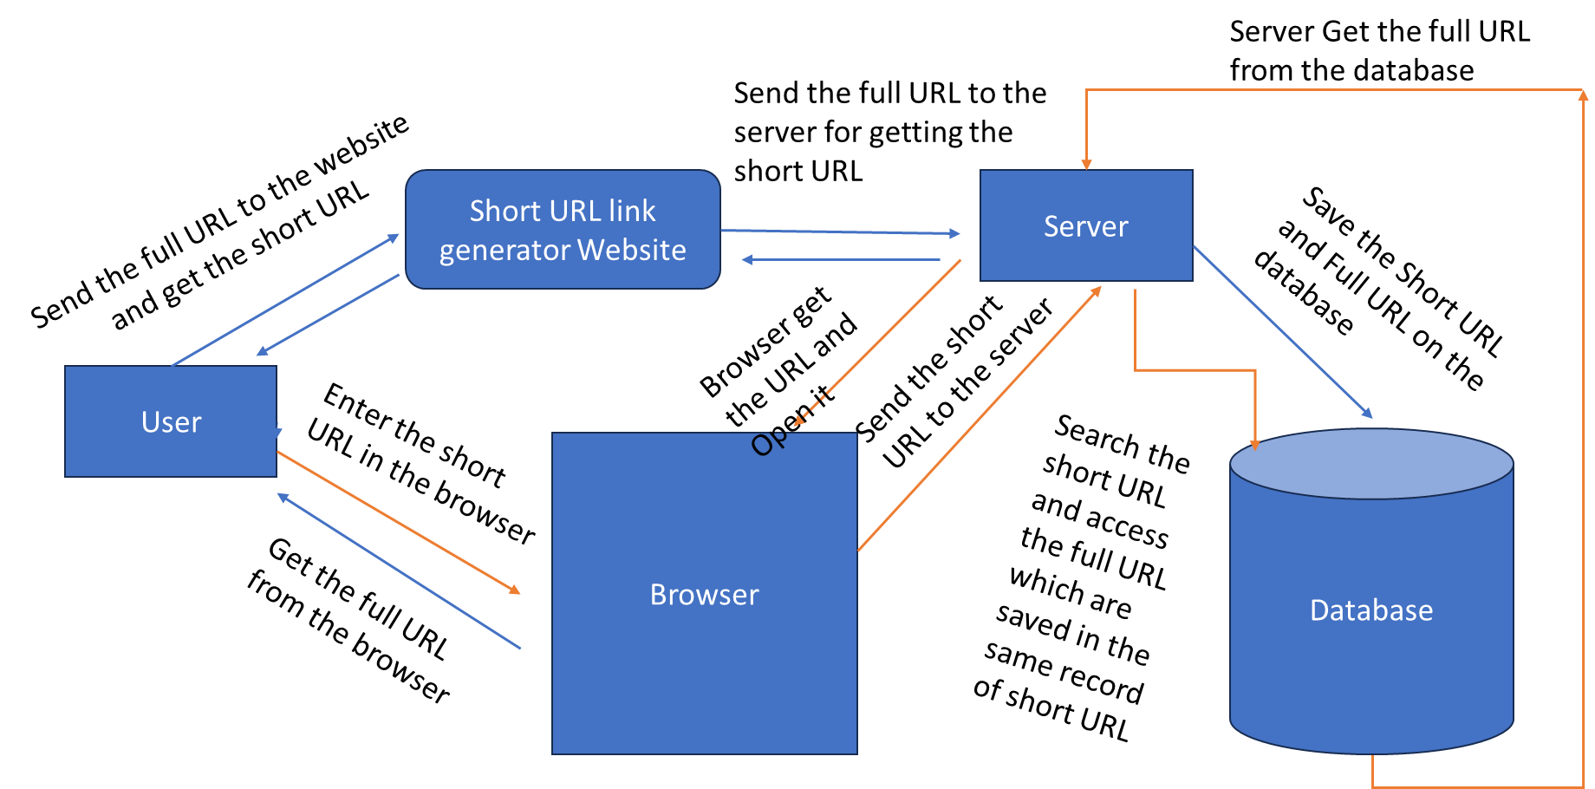

# Performance Test

The URL are not accessible if your database is close or stop. You first need to connect the database then server want to start. After Start the take care the server to be properly running then any one is able to access the short URLs.

These URLs are only accessed through clicked and cannot be accessed by typing in the address bar as because these URL are saved are on the local database and we are created the route for handle these URL this is one of the main limitations of this project.

Excepts this limitation our project is work very efficiently.

## Test Plan/ Test Cases

For testing Purpose, I have taken the true URLs and generate the short URL which accessed by me then it redirects to me to original/true website.

I have taken the URLs of two website as the test cases and then convert it into short URL and redirect to original or true website in this way passes the test case.

## Test Procedure

First of all, take the Full URL as the input for the website (for generating the short URLs).

Now access the short URL and check whether you are redirect to original to true website or not.

This is test procedure of whole project.

## Performance Outcome

The performance of this project is good at beginner or initial level but not so much as aspected.

# My learnings

I have learned this Course by dividing it into various steps-

* 1. **Basics of Python Language** : I have started my learning from the basics of python language and its syntax. The Basics of this language we mean Datatypes, type conversion, Operators , Control Statements, functions and various other concepts. After learning this language, I am able to enter in the programming field and become eligible for doing Competitive Programming.
  2. **Python Packages :** After Completion of basics of Python language, I have started to learn about Python Packages such as Pandas, Numpy, etc. which will help me for visualize or analyzing the data in future generation. Python Package also generate the interest in people to enter in the field of Data Science.
  3. **Flask Module :** After Completion of basics and packages of Python I have started to learn about Flask Module which helps in Web development. Flask helps the people or developer to provide the web like interface to user. Now a days some people also work as a web developer through python field with the help of Flask And Django.

I

# Future work scope

This Project has a very good scope in future. This Project is beneficial for future generation as because the upcoming generation was believed in smart work rather than hard work. They will face the problems in learning the URL specially whose length is too much.so they will need a solution to this problem, At that time this project might be helpful to all people to learn URL by shortening its length through the project. Not for Only Upcoming generation, This Project is also helpful for Our present generation specially for that type of people who faces memory problems.